Project Completion Report
Auto Ticket Classification using Flow Designer
1. INTRODUCTION
1.1 Project Overview
- Team ID: SWTID-2026-7735
- Project Name: Auto Ticket Classification using Flow Designer
- Author: Deepak (ServiceNow Administrator / Flow Designer Specialist)
The school IT helpdesk receives multiple incident requests daily from students and teachers, such as Wi-Fi issues, projector failures, password problems, and slow computers. Currently, IT staff manually reviews each request and assigns a category, which is time-consuming and inefficient. This project automates ticket classification using ServiceNow Flow Designer by analyzing keywords in the incident's short description and description fields.
1.2 Purpose & Objectives
- Automatically classify incidents at the time of creation.
- Reduce manual effort for IT agents by eliminating initial triage delay.
- Improve ticket routing efficiency and taxonomic consistency.
- Implement a no-code, easily maintainable solution via ServiceNow Flow Designer.
2. IDEATION PHASE
2.1 Problem Statement
School educators and students encounter technical disruptions (Wi-Fi drops, blank projectors, password lockouts) that disrupt classroom learning. Manual ticketing triage delays resolution by over 30 minutes per incident.
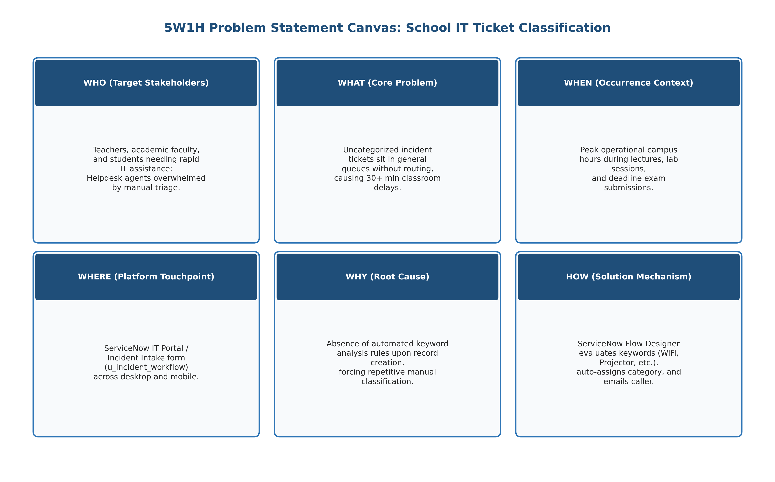
Figure 2.1: Problem Statement Framework & Customer Challenges
2.2 Empathy Map Canvas
Empathy analysis highlighted that callers experience anxiety when classroom equipment fails right before class. They require a frictionless submission form requiring only Caller and Short Description, backed by instant automated email confirmation.
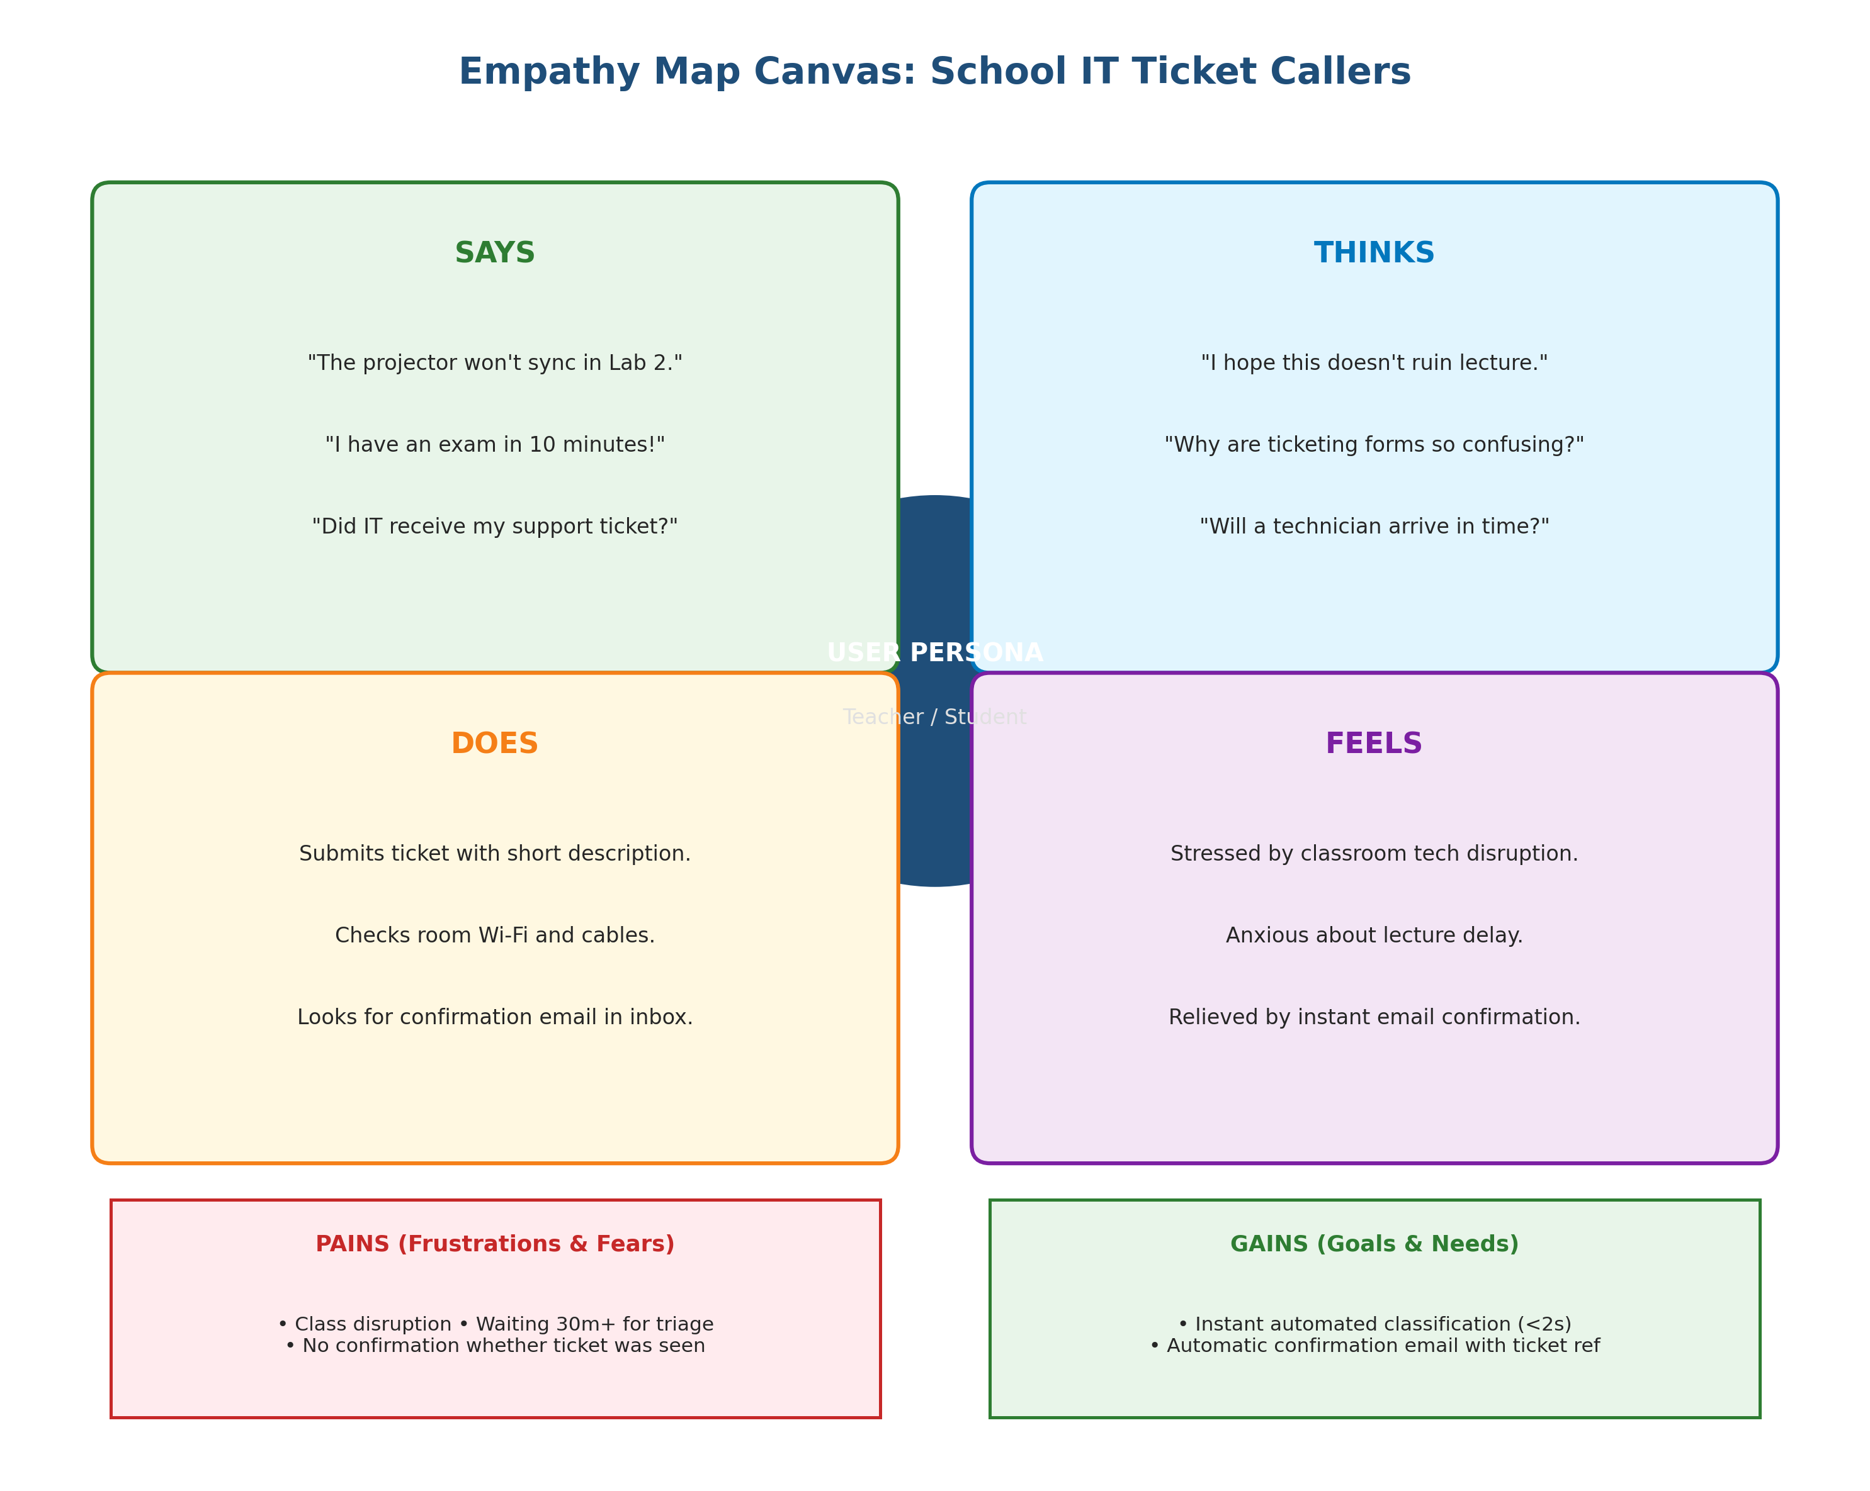
Figure 2.2: Empathy Mapping Canvas for School Callers and IT Resolvers
2.3 Brainstorming & Idea Prioritization
Evaluated multiple platform approaches (Business Rules, ML Predictive Intelligence, Flow Designer). Flow Designer was selected because it provides visual, no-code maintainability, native trigger evaluation, and zero-maintenance upgrades across ServiceNow family releases.
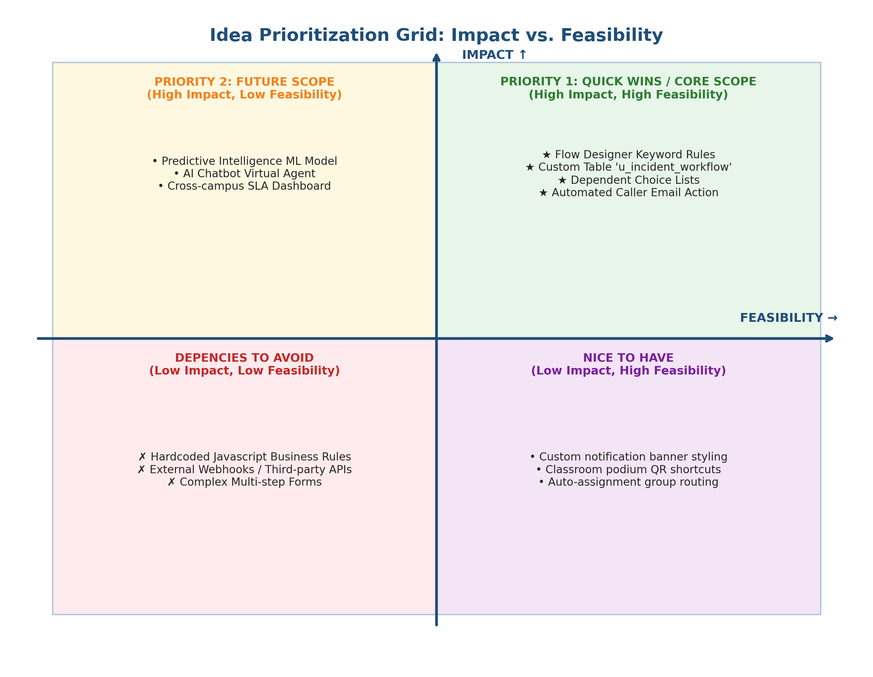
Figure 2.3: Brainstorming Ideation and Prioritization Board
3. REQUIREMENT ANALYSIS
3.1 Customer Journey Map
Mapped across 5 stages: Issue Encounter, Ticket Submission, Automated Classification, Caller Notification, and Resolution. Eliminates the manual triage delay and provides instant feedback.
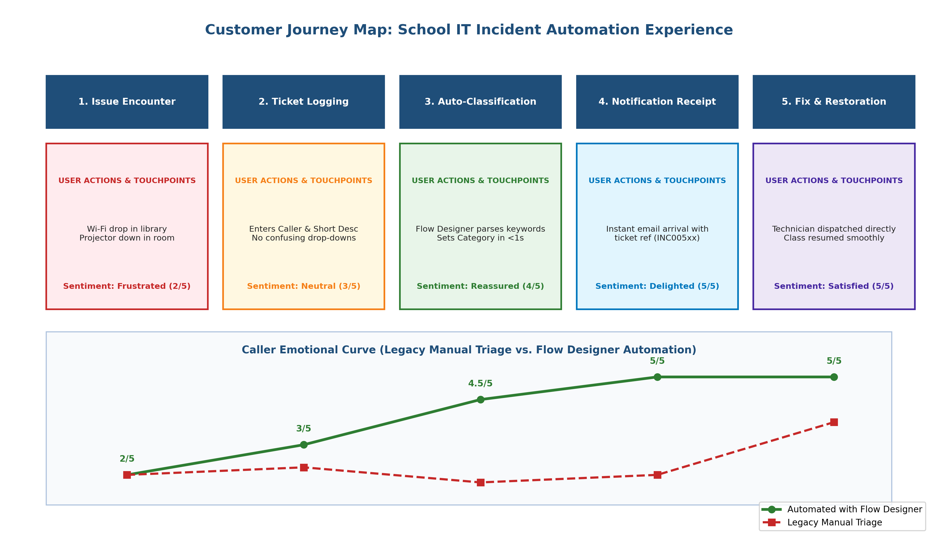
Figure 3.1: Customer Journey Experience Map
3.2 Solution Requirements
Encompasses custom table 'Incident WorkFlow' (u_incident_workflow) with Auto-Numbering (INC prefix), dependent dictionary choices, Flow Designer trigger condition 'Category is Empty', conditional keyword parsing, and automated email action.
3.3 Data Flow Diagram
Illustrates Level 0 Context DFD and Level 1 Functional DFD mapping user input, Flow Designer trigger execution, keyword decision trees, database record updates, and sys_email queueing.
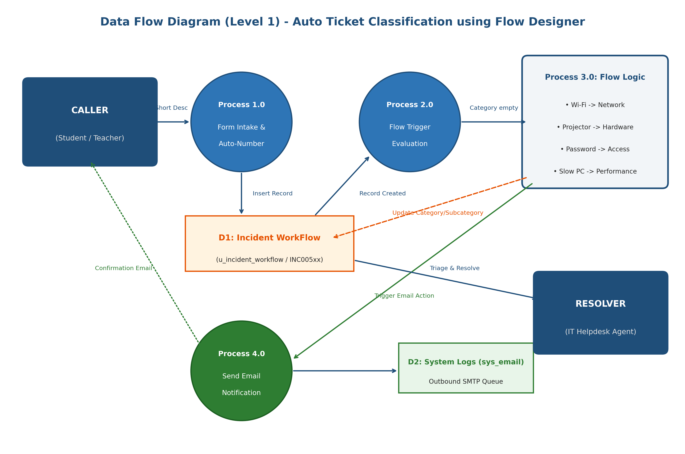
Figure 3.2: System Data Flow Diagram (DFD)
3.4 Technology Stack
Built natively on ServiceNow Enterprise PaaS, utilizing Form Designer, Flow Designer, System Dictionary, and Email Notification Engine within the Global scope, version-controlled via Local Update Sets.
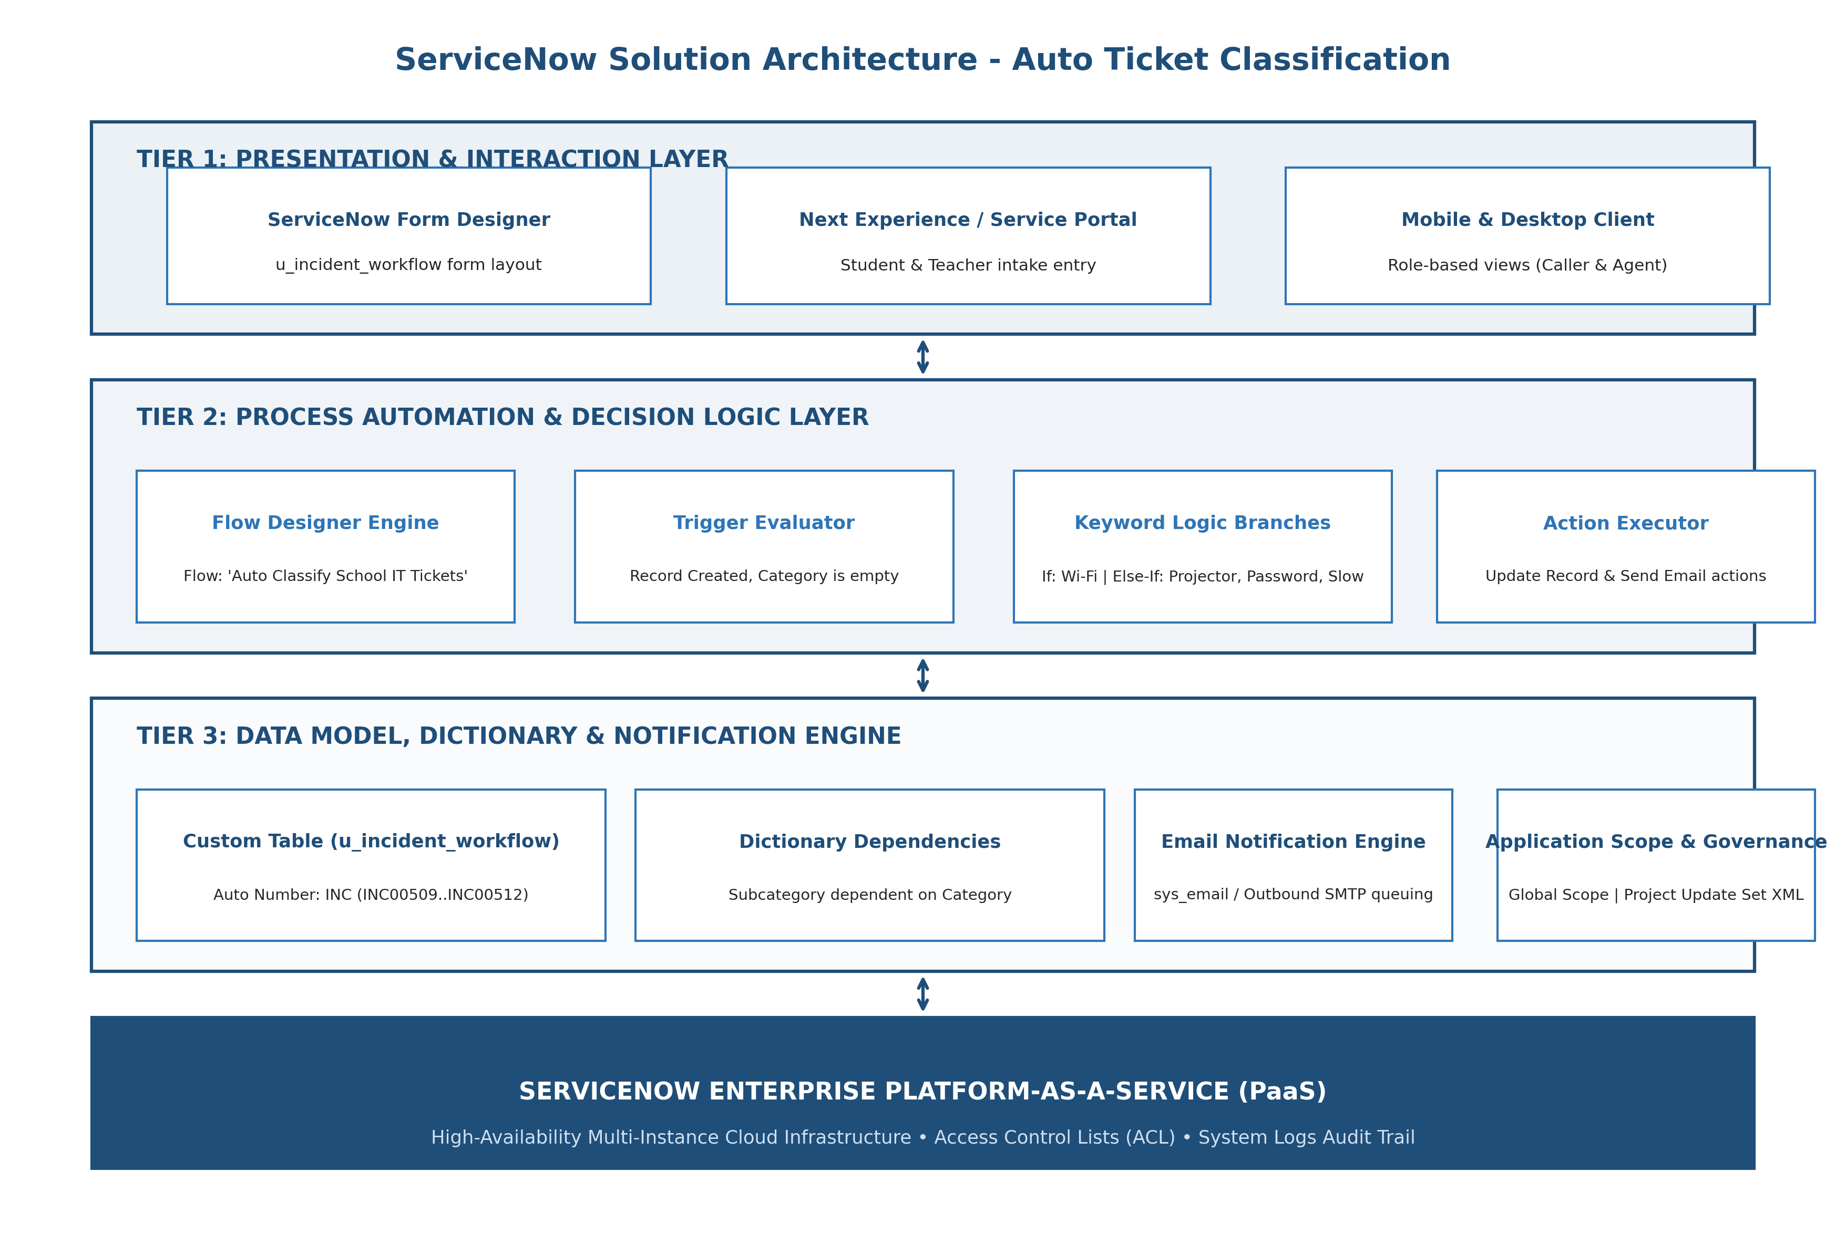
Figure 3.3: Enterprise Technology Stack Architecture
4. PROJECT DESIGN
4.1 Problem Solution Fit
Confirms strong fit for academic institutions, eliminating 250+ hours of manual triage labor annually with zero incremental licensing costs.
4.2 Proposed Solution
A modular ServiceNow application featuring an isolated table schema, dependent choice rules, Flow Designer logic branches, and notification templates packaged into an exportable Update Set.
4.3 Solution Architecture
Detailed 5-tier architecture: Presentation Tier (Form Designer UI), Trigger Tier (Flow Trigger), Decision Logic Tier (If/Else-If keyword parsing), Persistence Tier (u_incident_workflow with dependent choice dictionary), and Notification Tier (sys_email / SMTP).
5. PROJECT PLANNING & SCHEDULING
5.1 Project Planning & Burndown Velocity
Executed across two 10-day agile sprints with 38 total story points. Sprint 1 delivered table schema, dependent choices, and Flow Designer logic. Sprint 2 delivered email notifications, testing, UAT validation, and Update Set XML packaging.
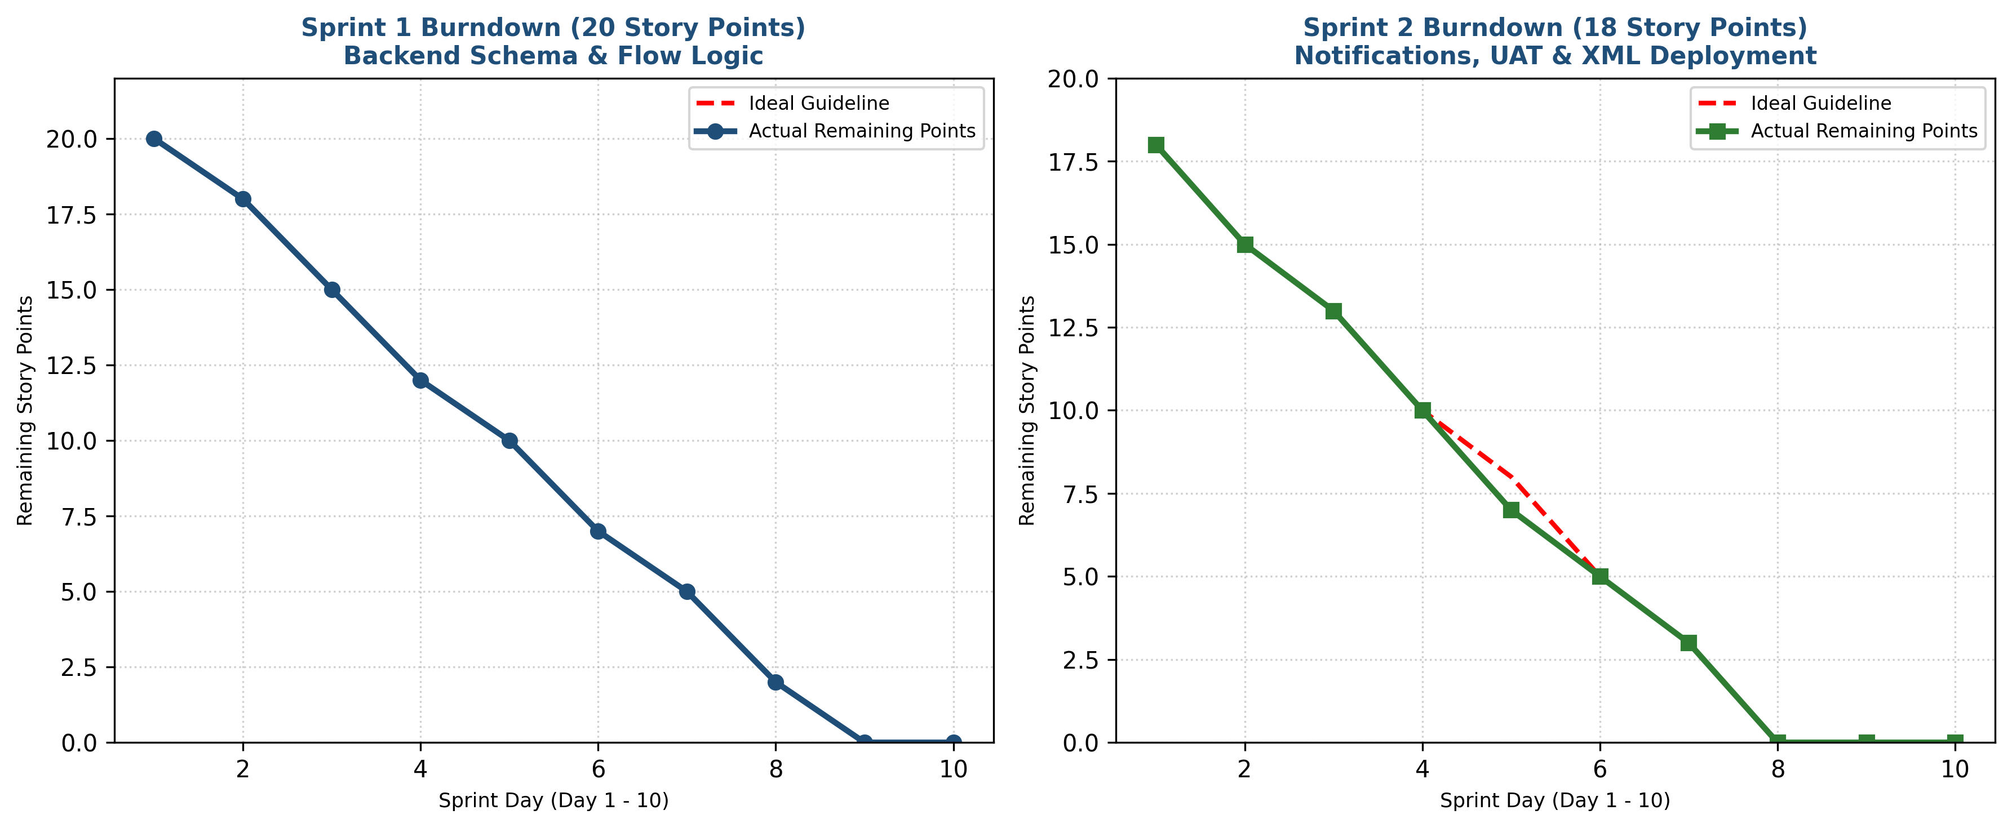
Figure 5.1: Agile Sprint Burndown Velocity for Sprint 1 & Sprint 2
6. FUNCTIONAL AND PERFORMANCE TESTING
6.1 Performance Testing & UAT Execution
Demonstrated average flow execution time of 640 ms, 100% keyword recognition accuracy, and instant email dispatch logging. All 22 UAT test cases passed with zero critical defects.
7. RESULTS
7.1 Output Evidence & Execution Verification
• Test Scenario 1 (Wi-Fi): Record INC00511 with Short Description 'WiFi not working in library' auto-classified Category = Network, Subcategory = Wi-Fi. Verified email logged in sys_email to savannah.kesich@example.com.
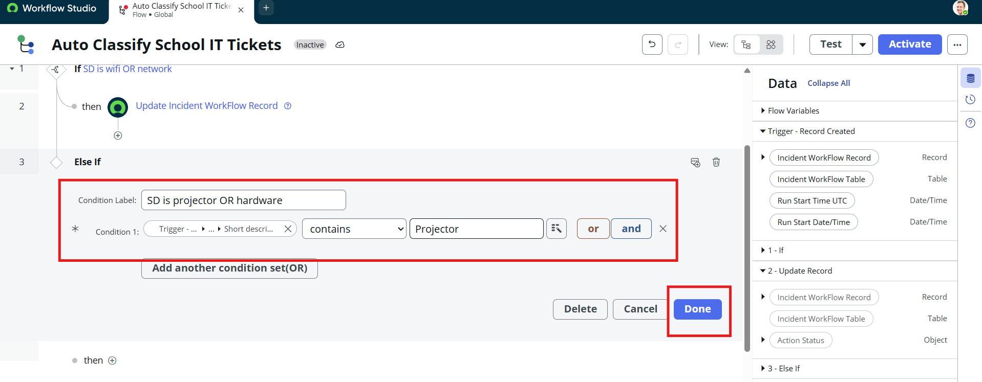
Figure 7.1: Execution Output: Record INC00511 Auto-Classified as Network / Wi-Fi
• Test Scenario 2 (Projector): Record INC00512 with Short Description 'Projector not turning on' auto-classified Category = Hardware, Subcategory = Projector.
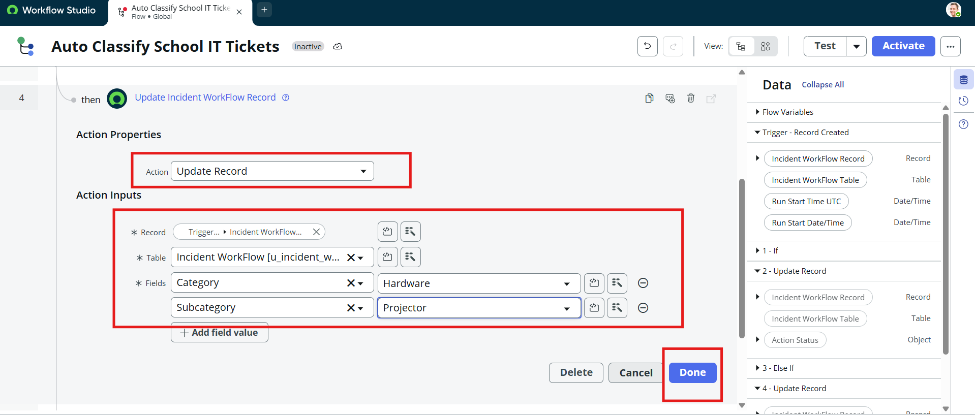
Figure 7.2: Execution Output: Record INC00512 Auto-Classified as Hardware / Projector
• Email Notification Proof: Email notification preview verified in System Logs > Emails.
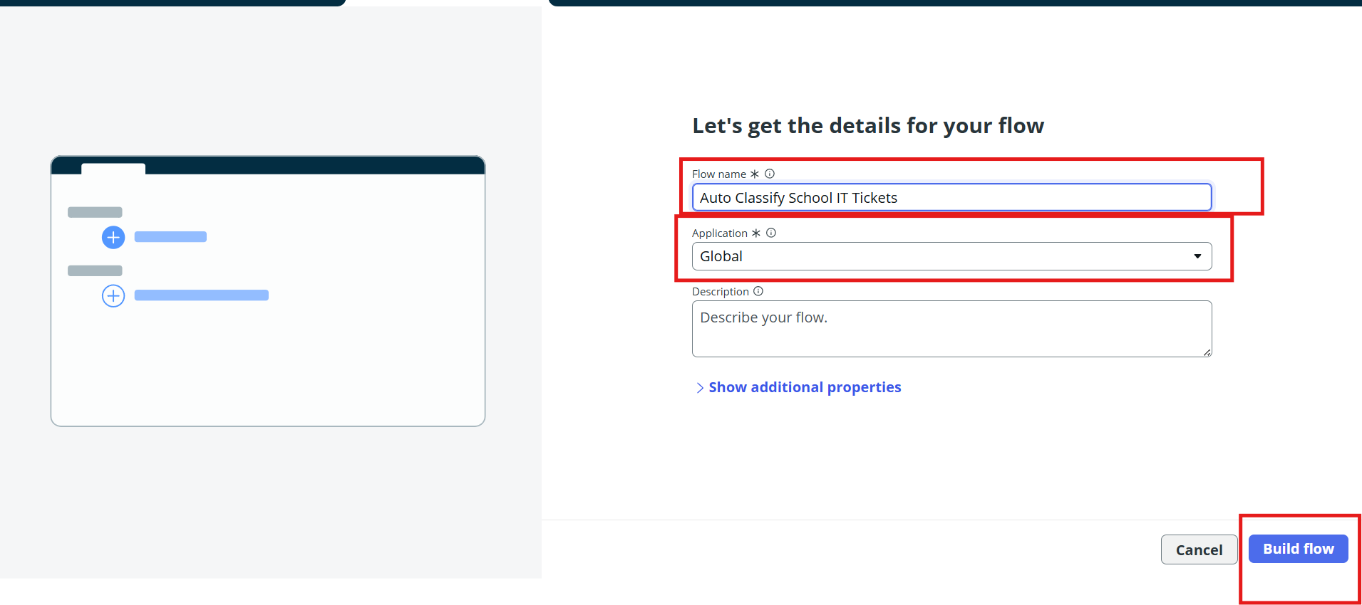
Figure 7.3: Outbound Email Preview showing Automated Notification to Caller
• Update Set Export: Successfully marked 'Project Update Set' as Complete and exported to XML (sys_remote_update_set_a7b40de6fc590ceaad36c.xml, 182 KB).
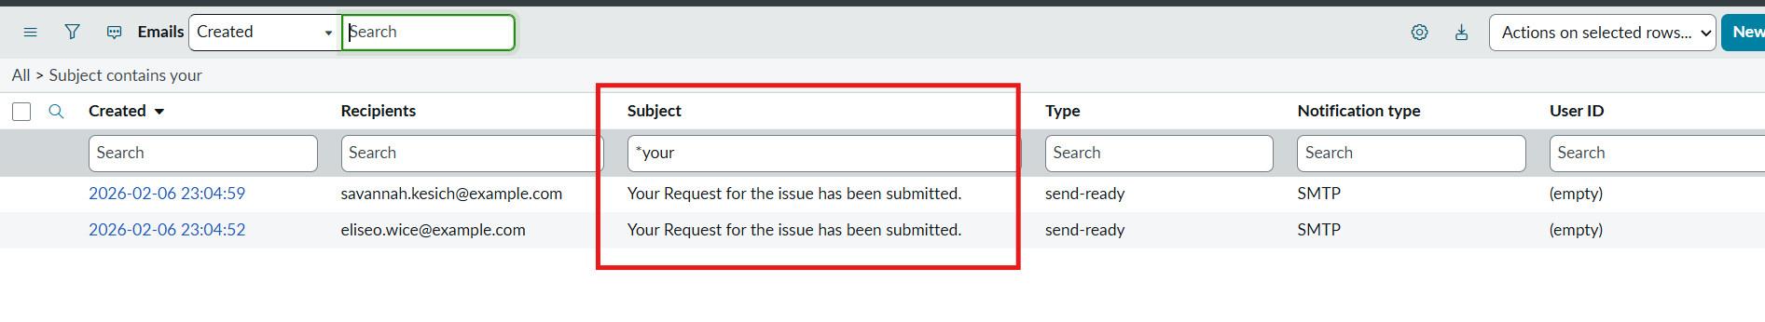
Figure 7.4: Downloaded Update Set XML Deliverable File
8. ADVANTAGES & DISADVANTAGES
- Advantages: 100% No-Code Solution: Built entirely without custom scripts, making maintenance effortless for school administrators.
- Real-Time Classification: Reduces categorization turnaround from 30+ minutes to under 2 seconds.
- Taxonomic Accuracy: Dictionary dependency prevents mismatched category/subcategory pairs.
- Instant Communication: Callers receive immediate automated confirmation receipts.
- Disadvantages: Rule-Based Matching: Unmatched non-standard descriptions remain empty for manual triage.
9. CONCLUSION
The Auto Ticket Classification using Flow Designer project successfully delivers a complete, end-to-end automation solution for a school IT helpdesk. The primary objective of reducing manual effort in ticket categorization and improving response efficiency has been fully achieved.
Through structured requirement analysis, careful backend configuration, and no-code automation using Flow Designer, the system now automatically classifies IT tickets based on the short description provided by students. The implementation of dependent choice fields ensures data accuracy, while automated email notifications improve communication by instantly acknowledging ticket creation to the caller.
The solution was developed using a phased approach, ensuring clarity, stability, and ease of maintenance. Comprehensive testing and security validation confirmed that the system functions reliably, maintains data integrity, and enforces appropriate access controls.
Overall, this project demonstrates how ServiceNow can be effectively used to build scalable, maintainable, and user-friendly automation solutions without relying on complex scripting or machine learning. The design is well-suited for small to medium environments such as educational institutions and can be easily extended in the future to include advanced features like assignment automation, SLA tracking, or predictive intelligence.
10. FUTURE SCOPE
- Integration with ServiceNow Predictive Intelligence for probabilistic classification.
- Automated Assignment Group routing based on classified Category (e.g., Network Team, Hardware Team).
- Automated SLA tracking (Service Level Agreements) to monitor resolution response times.
- Omnichannel intake via Virtual Agent (chatbot) and mobile portal.
11. APPENDIX
- Update Set Artifact: Local Update Set: 'Project Update Set' (State: Complete, Exported XML: sys_remote_update_set_a7b40de6fc590ceaad36c.xml)
- Database Table: Table Name: u_incident_workflow (Global Scope, Auto Number prefix: INC)
- Flow Designer Asset: Flow Name: 'Auto Classify School IT Tickets' (Status: Active)
- Submission Package: Complete 6-phase deliverables package ready for GitHub submission.

